ASSIGNMENT NO 11
1)Create a view that shows all of the customers who have the highest ratings
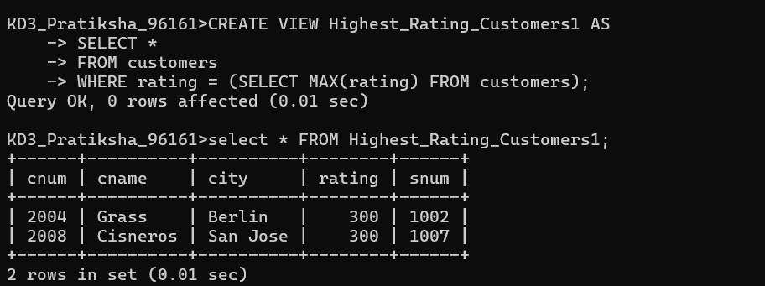
2)Create a view that shows the number of salespeople in each city
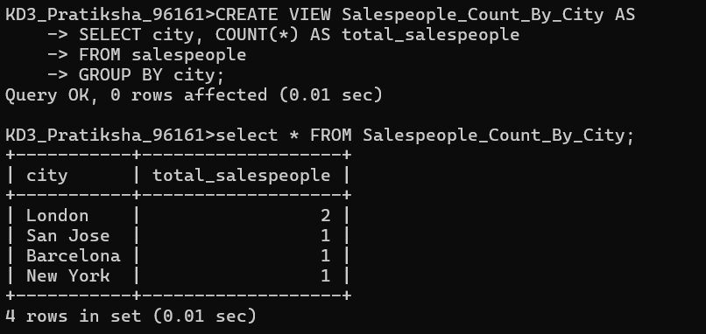
3)Create a view that shows the average and total orders for each salesperson after his or her name. Assume all names are unique.
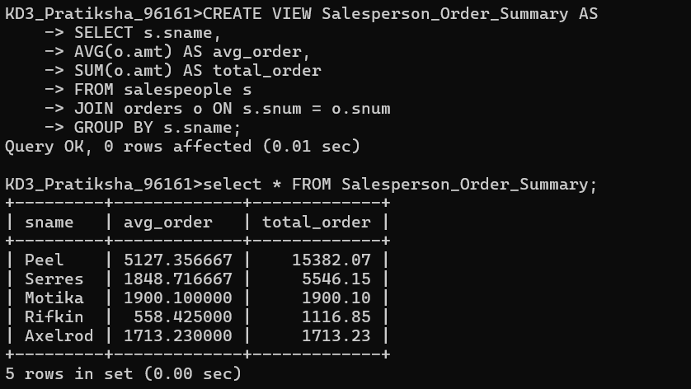

4)Create a view that shows each salesperson with multiple customers
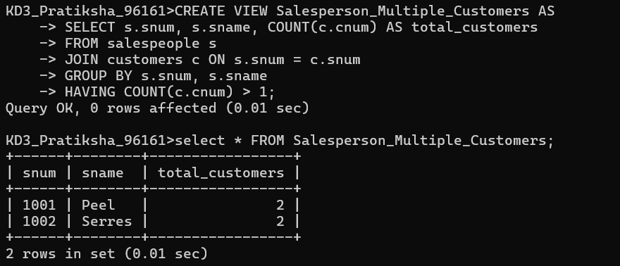
5)Which of these views are updateable (will allow DML operations)?
5.1: 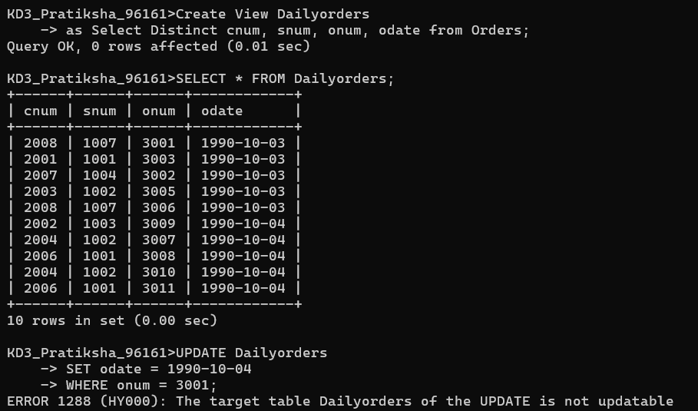
5.2:
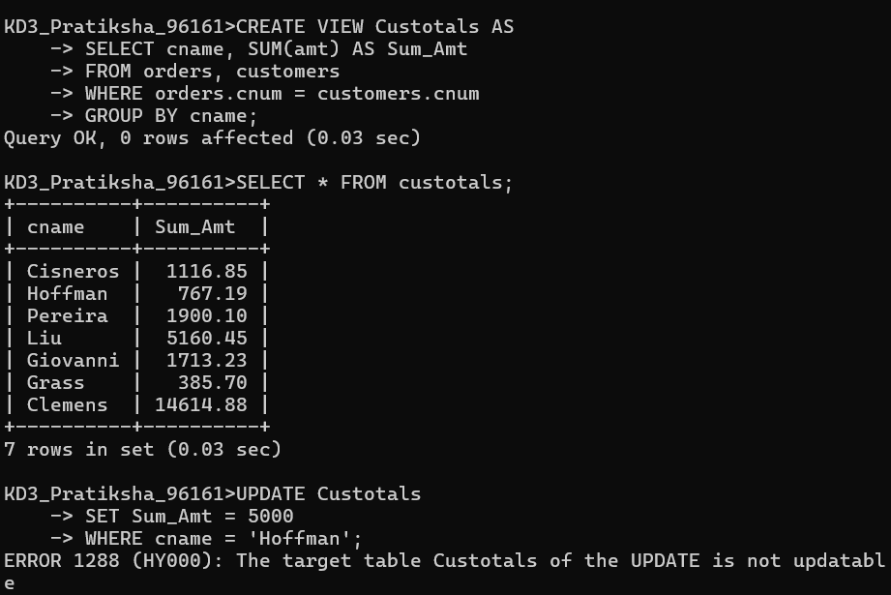

5.3:
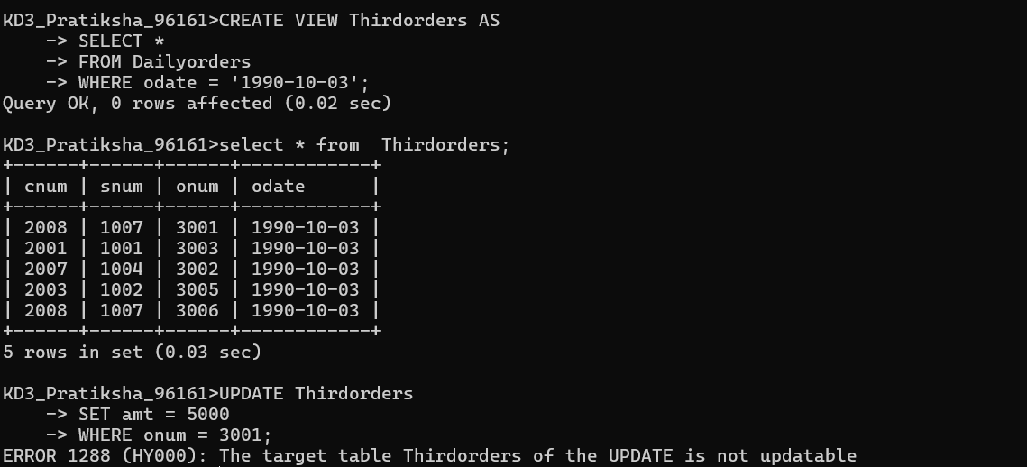

5.4:
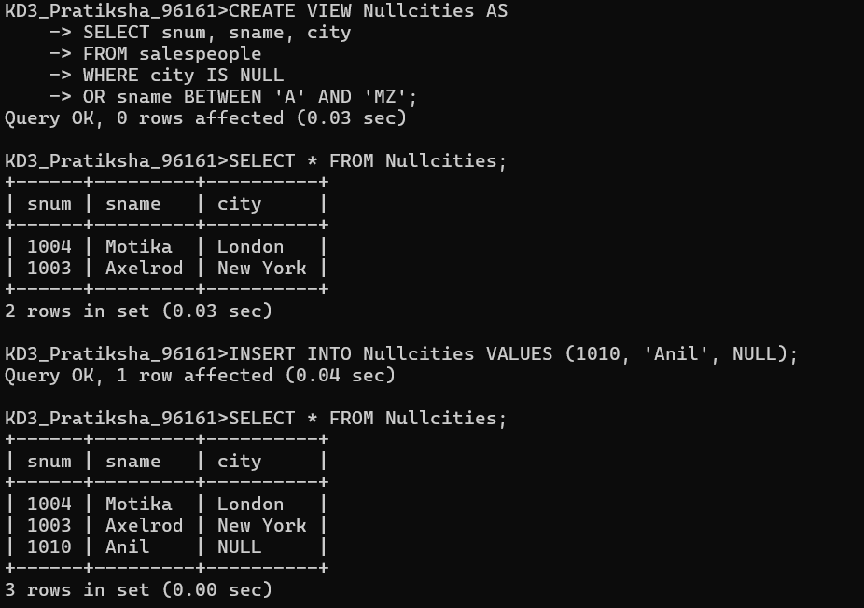

6)Create a view of the Salespeople table called Commissions. This view will include only
the snum and comm fields. Through this view, someone could enter or change
commissions, but only to values between .10 and .20.
